RESOLUTION NO.__________

RE: CERTIFICATE OF APPROPRIATENESS UNDER THE
PROVISIONS OF THE ACT OF THE PENNSYLVANIA
LEGISLATURE 1961, JUNE 13, P.L. 282 (53
SECTION 8004) AND BETHLEHEM ORDINANCE NO.
3952 AS AMENDED.

WHEREAS, it is proposed to install signs on front of building at 827 E. 4th Street.

NOW, THEREFORE, BE IT RESOLVED by the Council of the City of Bethlehem that a Certificate of Appropriateness is hereby granted for the work.

Sponsored by: (s)

(s)

ADOPTED BY COUNCIL THIS DAY OF

(s)
President of Council

ATTEST:

(s)
City Clerk

HISTORIC CONSERVATION COMMISSION

CASE # 496 – It is proposed to install signs on front of the building at 827 E. 4th Street.
OWNER/APPLICANT: DG Commons LLC. / Jizhen Fan

The Commission upon motion by Mr. Lader seconded by Mr. Evans adopted the proposal that City Council issue a Certificate of Appropriateness for the proposed work described herein:

- The proposal to install signs on front of the building at 827 E. 4th Street was presented by Jizhen Fan.

- The window sign will read “Healing Touch, Oriental Massage” with the telephone number. “Healing Touch” will be curved at the top with “oriental massage” and the phone number centered below (as sketched at the meeting).

- The sign will be in white vinyl lettering with red outline.

- There will be no signs in the window transoms.

- The sign will be no more than 40% of the area of the window glass as required by zoning.

- A scaled drawing of the sign as amended must be approved by the Historic Officer.

- An “OPEN” sign may be placed in the storefront window centered below the new vinyl sign. The sign may not flash or blink.

- The proposed motion was unanimously approved.
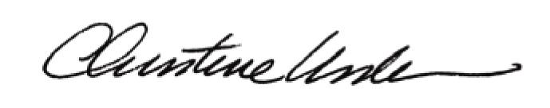

By:

Date of Meeting: April 21, 2014 Title: Historic Officer

